Scaling laws and compute-optimal models

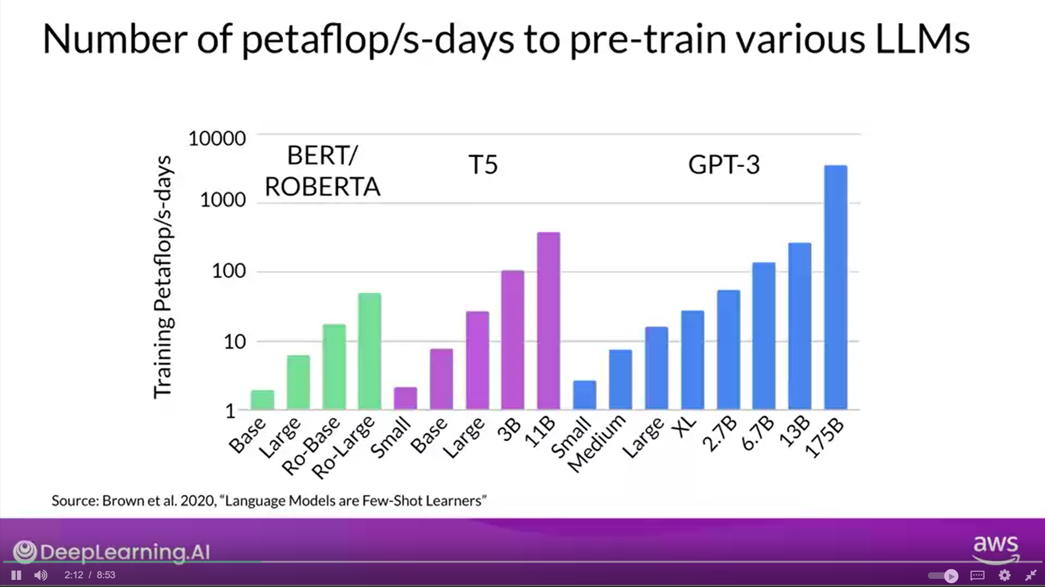

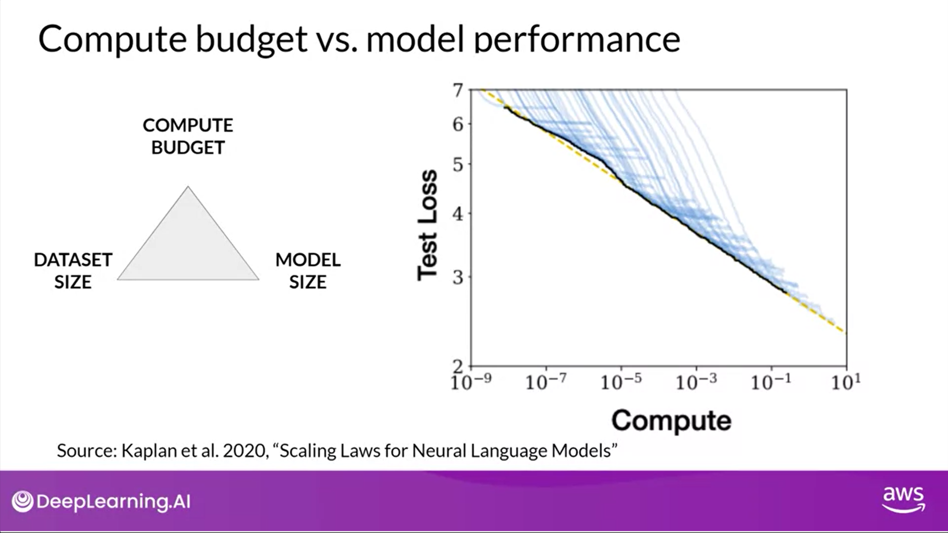

Compute Optimal Models

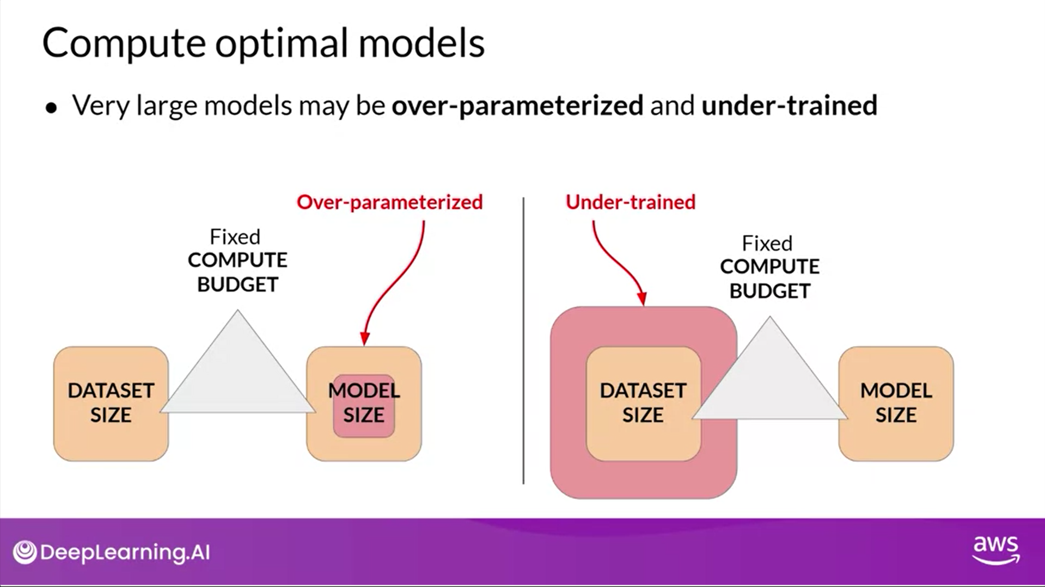

Models vs Time

